How to ‘Reply Privately’
Replying privately means that you are only messaging the sender of a message on a group forum. It’s best to ‘reply privately’ to whatsapp messages unless most members on the group need to see your response. This is particularly true if you’re booking onto an event. It makes it easier for everyone else on the whatsapp group to see important messages.

Below are three sets of guidance, depending on whether you look at whatsapp on an iphone, an android phone or a personal computer.

- iPhone
- Select message that you want to reply to – tap and hold on it.
- A drop down menu will appear. At the bottom of the menu will be the option ‘More’,
- Press on ‘More’ and a second menu will appear
- Select the second option ‘Reply Privately’
- Type your message and send!

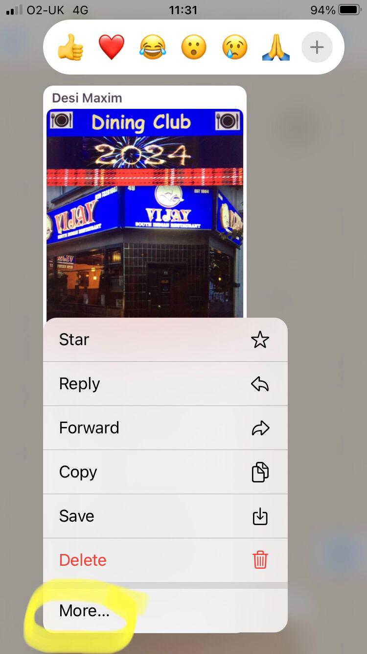

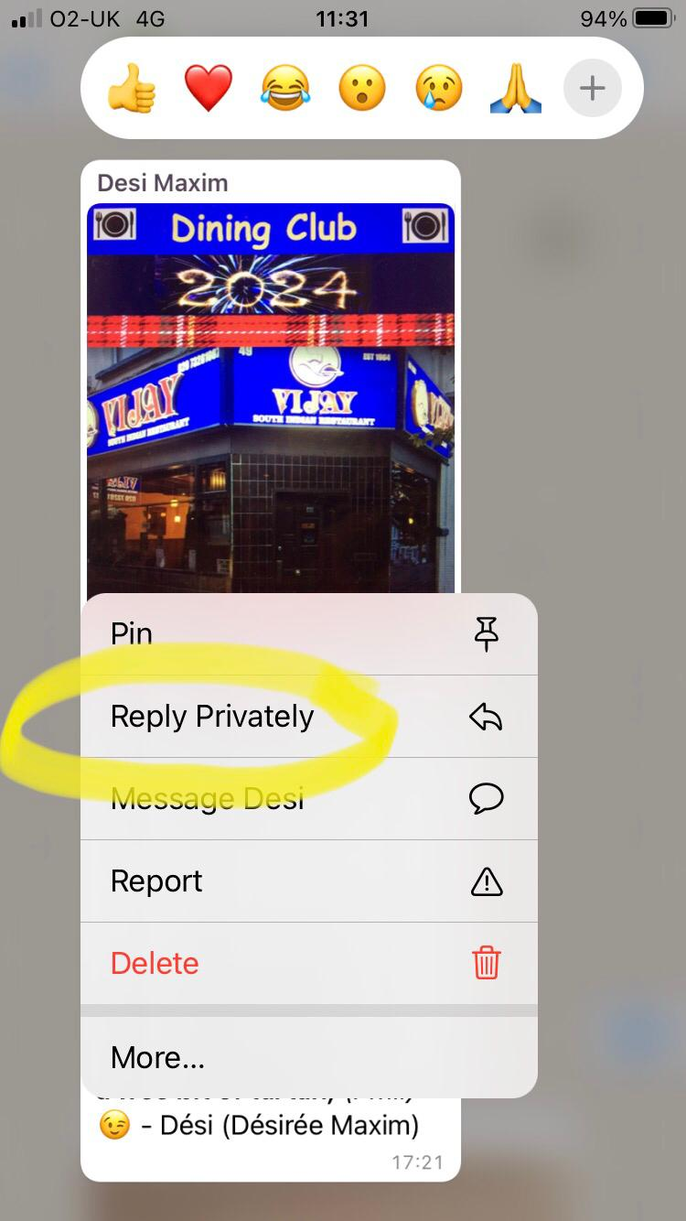

- Android phone
- Select message that you want to reply to. It might turn blue.
- Press gently on the ‘burger’ (three vertical dots) in the top righthand corner
- A drop down menu will appear
- Press on the second option “Reply Privately’
- Type your message and send!
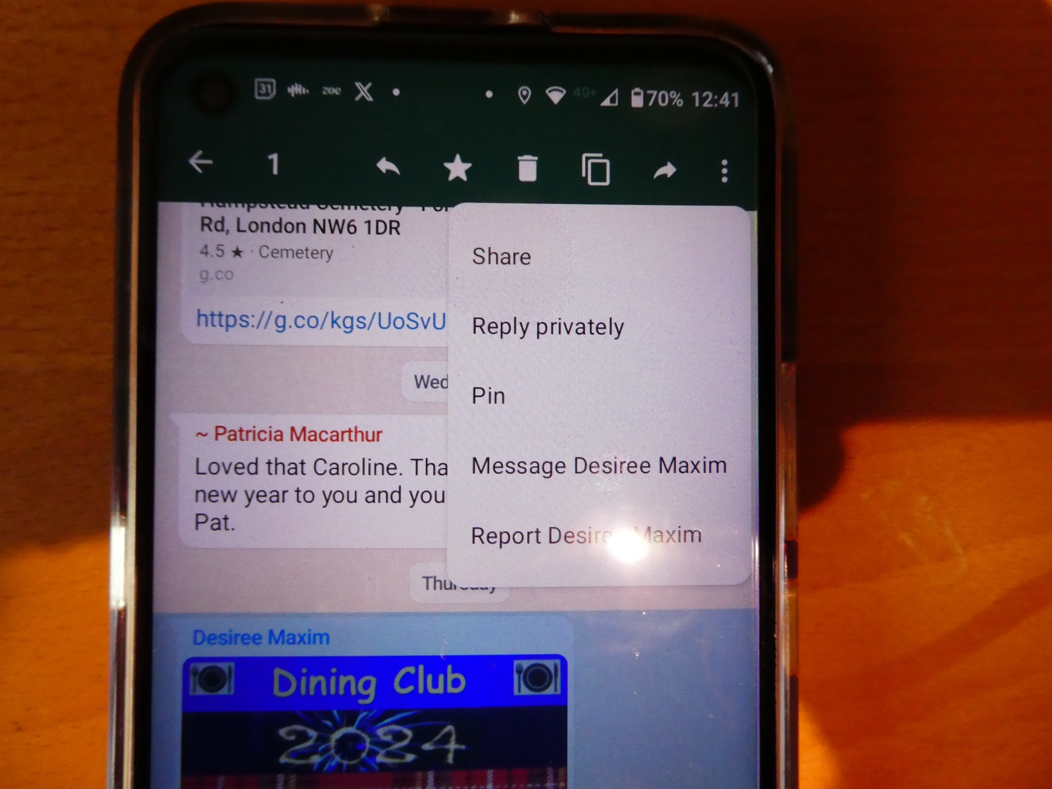

- Laptop
This is from a MAC laptop, so you may have to experiment if you have a pc.
- Select the arrowhead in the top righthand corner of the message
- A drop down menu will appear
- Press on the second option “Reply Privately’
- Type your message and send!

